**MICROSCOPES______________________________________________________________________________**

1. LABEL the main parts of the microscope?

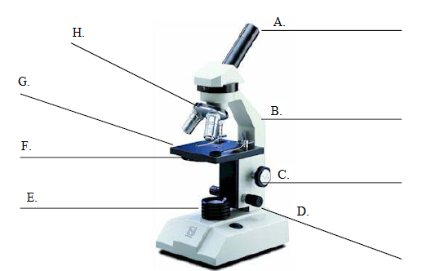

2. Any microscope that has two or more lenses is a ...

A. multi-dimensional microscope

B. multi-functional microscope

C. complex microscope

D. compound microscope

3. The part of the microscope the **arrow** is pointing to is called the …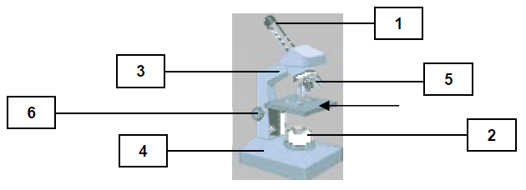

A. condenser lens B. diaphragm C. stage D. base

4. This part of the microscope provides different powers of magnification. It is identified by the number …

A. 6 B. 5 C. 2 D. 1

5. When you carry your microscope from place to place, you should hold it by this number and place your hand under this part - identified by this number...

A. 3, 5 B. 1, 6 C. 2, 3 D. 3, 4

6. The organization of units in a living organisms follows this pattern…

A. cells form organs, tissues, and systems

B. cells form tissues, organs, and systems

C. cells form systems, organs, and tissues

D. cells form organs, systems, and tissues

7. There are three factors that can affect your ability to see details of the internal parts of cells. The three factors include all of the following EXCEPT, the ….

A. number of cells

B. type of microscope

C. power of the lenses

D. quality of the prepared slides

8. When preparing slides to be used under the objective lens of the microscope you cover the specimen you are going to view with a …

A. glass slide B. drop of indicator C. toothpick D. cover slip

9. List the total magnification of the 3 objective lenses and how they are calculated.

Low power:

Medium power:

High power:

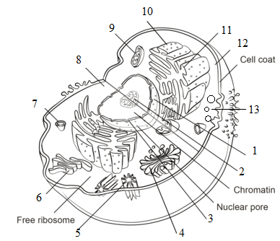**CELLS_____________________________________________________________________________________________________**

10. The illustration shown is what kind of cell…

A. Animal C. Bacteria

B. Plant D. Virus

11. Label number 12 is pointing to the...

A. Plasma membrane C. Cytoplasm

B. Nuclear Membrane D. Nucleolus

12. The 'control centre' of the cell where DNA is found is indicated by label number..

A. 1 B. 2 C. 3 D. 7

13. Which label is pointing to the 'nuclear membrane'?

A. A. 4 B. 3 C. 2 D. 5  
  
14. This storage compartment is indicated by label number ...   
A. 5 B. 13 C. 2 D. 7

15. The function of label #9is to …

A. direct all activities in the cell - The ‘Command Center’

B. convert energy into useable forms – ‘The Powerhouse’

C. control the flow of nutrients – ‘The Gateway’

D. Store nutrients the cell needs – ‘The Storage Room”

16. [What organelle does a plant cell have that an animal cell does not have, that supports the cell and is the outer most layer?](http://www.proprofs.com/discuss/q/129148/what-organelle-does-plant-cell-have-that-animal-not-supports)

A. Cell Wall B. Cell membrane C. Nuclear membrane D. Nuclear wall  
  
17. What is the name of the organelle that contains chlorophyll and is only found in plant cells?

A. Cell Wall B. Central Vacuole C. Chloroplasts D. Centriole

18. What is the difference in the vacuoles of both plant and animal cells?

A. Animal cells- contain only waste Plant cells- contain only water

B. Animal cells- small vacuoles Plant cells- vacuoles make up 90% of cell

C. Animal cells- vacuoles make up 90% of cell Plant cells- small vacuoles

D. Animal cells- contain only water Plant cells- contain only waste

E. Vacuoles are the same in both plant and animal cells

19. Which of the following best describes cellular respiration?

A. glucose + oxygen 🡪 carbon dioxide + water + energy

B. glucose + oxygen + energy 🡪 carbon dioxide + water

C. carbon dioxide + water 🡪 glucose + oxygen + energy

D. glucose + carbon dioxide 🡪 oxygen + water + energy

20. A process which enables substances to spread out, throughout a solution, eventually becoming evenly distributed in the solution, is called...

A. distillation B. dissolving C. desalination D. diffusion

21. Osmosis is the diffusion of water through a selectively permeable membrane. This process occurs because water will move from an area of...

A. low concentration to high concentration

B. high concentration to low concentration

C. low concentration to low concentration

D. high concentration to high concentration

|  |  |
| --- | --- |
| ______ bacteria | 1. Movement of particles from high concentration to low concentration |
| ______ cell | 1. Plant organelle that makes energy from the Sun |
| ______ cell membrane | 1. Thin covering the protects the cell from its surroundings |
| ______ cell wall | 1. Cell parts that assemble proteins |
| ______ chloroplast | 1. Structure in the cell the packages proteins |
| ______ cytoplasm | 1. Controls the activities of the cell |
| ______ diffusion | 1. Jelly-like substance within the cell |
| ______ Golgi Body | 1. Movement of water from high concentration to low concentration |
| ______ Mitochondria | 1. Basic unit of life |
| ______ Nucleus | 1. Temporary storage compartments in cells |
| ______ Organelle | 1. Where cellular respiration takes place |
| ______ osmosis | 1. Tough structure that surrounds a plant cell |
| ______ ribosome | 1. Tiny non-living particles that use other cells for reproduction |
| ______ selectively permeable | 1. A cell part with a specific function |
| ______ vacuole | 1. Allows only some materials to pass through |
| ______ virus | 1. Single celled micro-organism, may cause disease |

**BODY SYSTEMS________________________________________________________________________________________**

22. What are the 5 levels of organization in your body, from smallest to largest?

_______________ 🡪 _______________ 🡪 _______________ 🡪 ______________ 🡪 ______________

23. What are the 4 stages of digestion, in order? Describe each stage.

1. 3.

2. 4.

24. Label the following diagrams.

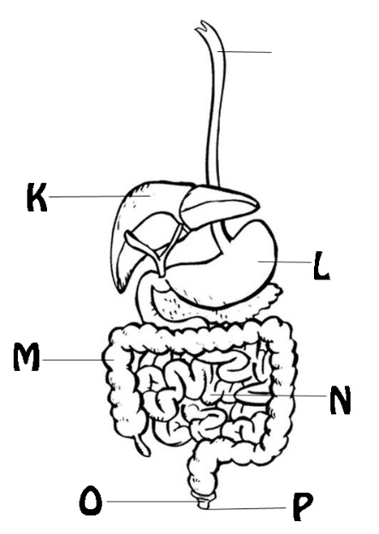

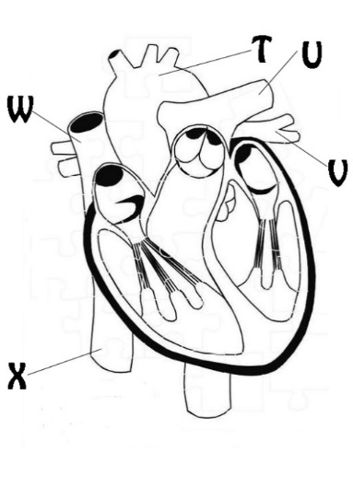

25. What are the five types of blood vessels? Give a brief description.

|  |  |
| --- | --- |
|  |  |
|  |  |
|  |  |

26. Label the diagram below with the following terms.

|  |  |  |  |
| --- | --- | --- | --- |
| left atrium | right atrium | vein | lung capillaries |
| left ventricle | vein | artery | body capillaries |
| artery | right ventricle | heart |  |

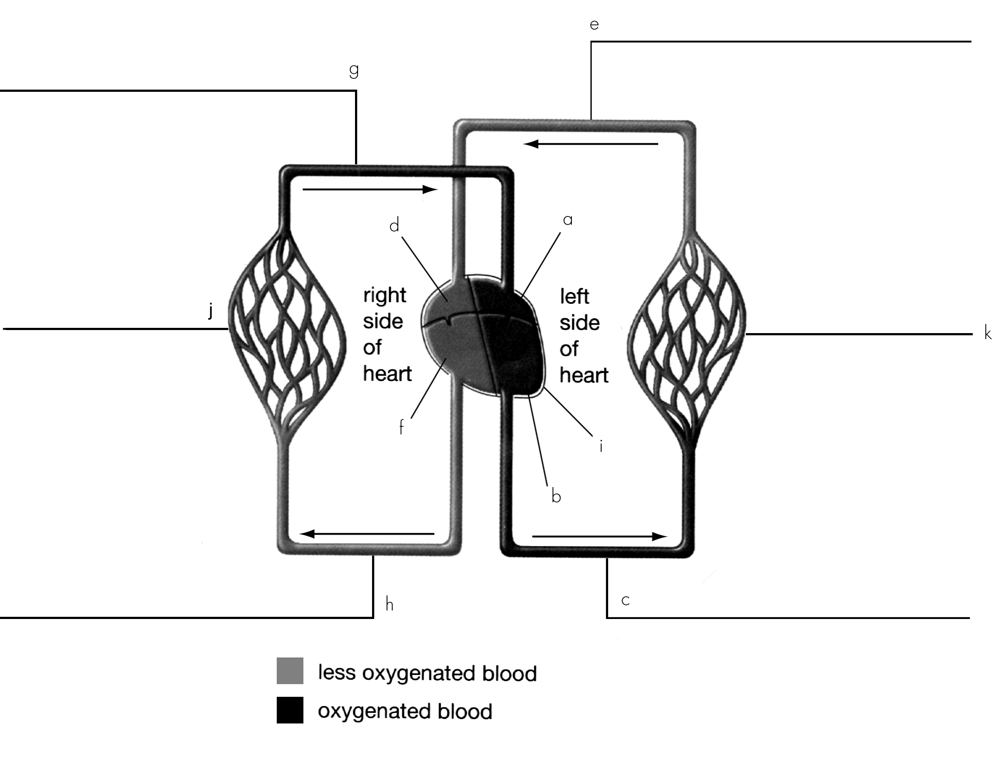

27. On the diagram, draw arrows to show the direction of blood flow in the different blood vessels and through the four chambers of the heart.

28. Which side of the heart collects blood from the body and pumps it to the lungs? _________________________________

29. Which chamber receives blood from the lungs? _________________________________

30. Which ventricle is more muscular, the right or the left? Explain.

______________________________________________________________________________

31. What is the function of red blood cells? __________________________________________________________________

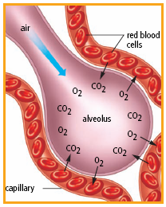32. What exchange takes place in the Diagram on the right? ____________________________

33. There are millions of _____________________ at the ends of the ___________________, and this is where gas exchange takes place.

34. These 2 gases, ________________ and ______________________________ move back and forth between the alveoli and the surrounding __________________________________

|  |  |
| --- | --- |
| ______ arteries | 1. Moves blood throughout the body |
| ______ capillaries | 1. Vessel that takes blood away from the heart |
| ______ circulatory system | 1. Group of tissues working together |
| ______ digestive system | 1. Liquid and gas wastes are removed from the body |
| ______ excretion | 1. Tiny thin walled blood vessels |
| ______ gas exchange | 1. Vessel that returns blood to the heart |
| ______ nutrients | 1. Supplies the blood with oxygen |
| ______ organ | 1. Organs that work together to get nutrients from food |
| ______ organ system | 1. Group of cells that have same structure and function |
| ______ respiratory system | 1. Substance needed by the body ex. Fat, vitamins |
| ______ tissue | 1. Process between the alveoli and the capillaries |
| ______ veins | 1. Group of organs working together |

**IMMUNE SYSTEM_______________________________________________________________________________________**

35. A vaccine works by stimulating your immune system to

A. produce more antigens

B. reduce the number of T cells

C. reduce the number of B cells

D. produce more antibodies

36. HIV is not transmitted by

A. blood B. semen C. dirty needles D. shaking hands

37. AIDS is caused by

A. bacteria B. virus C. semen D. blood

38. In a severe allergic reaction

A. a person may have great trouble breathing

B. the immune system needs to make more antibodies

C. a person could die from infection

D. the immune system cannot trigger the cells

39. HIV attacks

A. the helper T cells B. the killer T cells C. the blood D. the semen

40. Which of the following terms best represents a disease-causing organism?

A. pathogen B. antigen C. antibody D. plaque

41. Pathogens are kept out of your respiratory system by

A. mucus B. sweat C. oils on your skin D. gastric juice

42. Pathogens on the skin can be killed by

A. sweat B. oils on your skin C. A and B D. neither A nor B

43. How does gastric juice help the immune system?

* 1. Gastric juice produces killer T cells.
  2. Gastric juice produces antibodies.
  3. Gastric juice destroys pathogens.
  4. Gastric juice creates inflammation.

44. Inflammation can be considered

1. part of the innate immune response
2. part of the acquired immune response
3. part of active immunity
4. a result of the mobilization of B cells

45. What is the correct order of the human immune response to a pathogen?

* 1. Recognition, disposal, mobilization, immunity
  2. Recognition, mobilization, disposal, immunity
  3. Recognition, immunity, disposal, mobilization
  4. Recognition, disposal, immunity, mobilization

46. What cells produce antibodies?

A. B cells B. T cells C. white blood cells D. red blood cells

47. Why are white blood cells sent to the part of the body that is infected by pathogens?

A. to heal the infection

B. to supply blood to the infected area

C. to provide immunity

D. to destroy the pathogens

48. What are the two types of immune response?

A. first line and second line

B. innate and acquired

C. pathogen and antigen

D. direct and indirect

49. What is the role of antibodies?



A. I, II, and III only

B. II, III, and IV only

C. I, III, and IV only

D. I, II, III, and IV

50. The role of helper T cells is

A. find antigens and signal B cells to produce antibodies

B. wipe out antigens and pathogens on their own

C. both A and B

D. neither A nor B

|  |  |
| --- | --- |
| ______ antibody | 1. Substance the body cannot recognize |
| ______ antigen | 1. Cells that fight disease |
| ______ immune system | 1. Particles made by the immune system to destroy invaders |
| ______ pathogen | 1. Defends the body against infection |
| ______ white blood cell | 1. Quick and non-specific |
| ______ vaccine | 1. Response involving swelling and fever |
| ______ first line of defense | 1. Organism that can cause a disease |
| ______ acquired response | 1. High sensitivity to a substance |
| ______ innate response | 1. Slow and specific |
| ______ allergy | 1. Skin, mucus, gastric juice |
| ______ inflammation | 1. Injected weakened particles to help defend against infection |