**STATES OF MATTER & KINETIC MOLECULAR THEORY ____________________________________________________**

Name: ___________________

1. Define the following terms in your own words

|  |  |
| --- | --- |
| 1. Matter |  |
| 1. Mass |  |
| 1. Density |  |
| 1. Volume |  |

1. What equipment is used to measure mass? __________________________ Units? __________________
2. What equipment is used to measure volume? __________________________ Units? ________________
3. Which of the following is not an example of matter?
4. Heat B. solids C. water D. oxygen
5. What does the kinetic molecular theory explain?
6. How particles act when their spacing and movement change
7. How to determine the mass and volume of solids, liquids and gases
8. How the kinetic energy in solids, liquids and gases can be measured
9. How to find out the temperature of solids, liquids and gases
10. What happens to matter when energy is added to it?
11. The particles take up less space C. The particles move around faster
12. The particles decrease the volume D. The particles move around slower
13. Complete the following table:

|  |  |  |  |
| --- | --- | --- | --- |
|  | Fixed Shape?  (Yes or No) | Fixed Volume?  (Yes or No) | Diagram |
| 1. SOLID |  |  |  |
| 1. LIQUID |  |  |  |
| 1. GAS |  |  |  |

1. A full cup of tea is 85oC and a full swimming pool is 50oC. What of the following is true?
   1. The tea has a higher temperature and less heat compared to the swimming pool
   2. The tea has a higher temperature and more heat compared to the swimming pool
   3. The tea has a lower temperature and less heat compared to the swimming pool
   4. The tea has a lower temperature and more heat compared to the swimming pool

1. Which of the following occurs during thermal expansion?
   1. The particles decrease in volume C. The particles move around faster
   2. The particles increase in volume D. Both B and C
2. Which of the following phase changes is heat released/removed?
3. Melting C. Evaporation
4. Condensation D. Sublimation

|  |  |
| --- | --- |
| 1. ______ condensation | 1. amount of matter in an object |
| 1. ______ density | 1. change of state from gas to solid |
| 1. ______ evaporation | 1. change of state from gas to liquid |
| 1. ______ thermal contraction | 1. mass in a given volume |
| 1. ______ mass | 1. change of state from liquid to solid |
| 1. ______ melting | 1. change of state from liquid to gas |
| 1. ______ solidification | 1. amount of space taken up by an object |
| 1. ______ deposition | 1. increase in volume resulting, particles further apart, less dense |
| 1. ______ sublimation | 1. change in state from solid to liquid |
| 1. ______ volume 2. ______ thermal expansion | 1. change of state from solid to gas 2. decrease in volume, particles closer together, more dense |

**ATOM_____________________________________________________________________________________________________**

1. Fill in the Blanks. Use each of the following terms

***electron*, *negative*, *neutron*, *proton*, *nucleus*, *positive, subatomic particles, surrounding the nucleus, zero***

1. Atoms can be split into smaller, simpler particles called_________________________________

There are 3 subatomic particles:

1. ____________________ (p+) have a ______________________ charge
2. ____________________ (n0) have _______________________ charge
3. ____________________ (e-) have a _______________________ charge and found _______________________________

e) Protons and neutrons are located in the center of the atom in an area called the **_____________________________**_

1. Which of the following is true about Elementary particles?
   1. Have fractional charges C. Consist of leptons
   2. Consist of quarks D. A,B,C are all true
2. Protons are made up of :
3. Leptons B. Quarks C. Electrons D. Neutrons
4. Which of the following is an elementary particle? :
5. Proton B. Neutron C. Electron D. Both A and B

|  |  |
| --- | --- |
| 1. ______ proton | 1. Consists of two down quarks and one up quark |
| 1. ______ neutron | 1. Are very small negatively charged particles |
| 1. ______ electron | 1. Consists of two up quarks and one down quark |
| 1. ______ subatomic particle | 1. A type of elementary particle |
| 1. ______ elementary particle 2. ______ quark 3. ______ nucleus 4. ______ lepton | 1. The most basic unit of matter consisting of leptons and quarks 2. Consists of electrons, protons, and neutrons 3. Makes up protons and neutrons 4. Consists of protons and neutrons |

**CLASSIFYING MATTER____________________________________________________________________________________**

1. Matter can be separated into two main categories which are:
2. Mixtures and Compounds C. Mixtures and Pure Substances
3. Elements and Suspensions D. Compounds and Elements
4. Another name for a homogenous mixture is a _______________
5. Compound B. Solution C. Pure Substance D. Element
6. Which of the following can be physically separated?
7. Compound B. Element C. Pure Substance D. Mixture
8. Classify the following as elements (E), compounds (C) or Mixtures (M)

|  |  |  |
| --- | --- | --- |
| 1. ______ Air | C. ______ Sugar (C6H12O6) | E. ______ Copper metal (Cu) |
| B. ______ Iron metal (Fe) | D. ______ Milk | F. ______ Salt (NaCl) |

1. Classify the following as Solution (Sp), suspension (Sp) or Colloid (C)

|  |  |  |
| --- | --- | --- |
| 1. ______ apple juice | D. ______ fog | G. ______ Pop |
| B. ______ chicken noodle soup | E. ______ trail mix | H. ______ milk |
| C. ______ mayonnaise | F. ______ Italian dressing | I. ______ perfume |

1. Match the picture with the correct term:

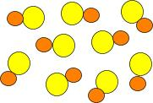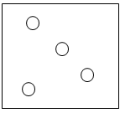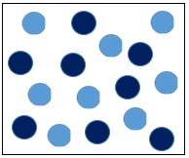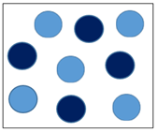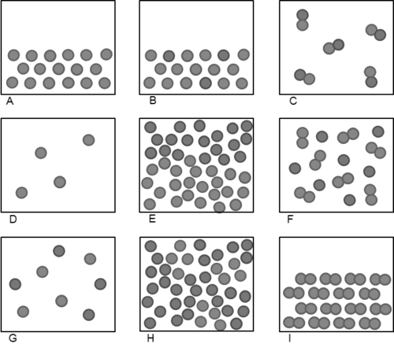

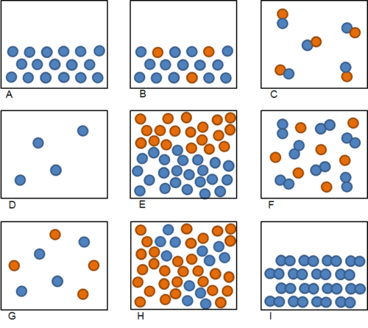



I II III IV V

1. _____ Solution B. _____ Compound C. _____ Element D. _____ Suspension E. _____Colloid

|  |  |
| --- | --- |
| 1. ______ Pure element | 1. Very small well mixed particles; one substance is dissolved in another |
| 1. ______ Mixture | 1. A major division of matter that cannot be physically separated |
| 1. ______ Compound | 1. Have medium sized particles that have not dissolved |
| 1. ______ Pure Substance | 1. Contains 2 or more elements that can be chemically separated |
| 1. ______ Homogenous mixture 2. ______ Heterogeneous mixture 3. ______ Suspension 4. ______ Colloid | 1. A major division of matter that can be physically separated 2. Contains identical atoms 3. Particles are large and will separate over time 4. Is not uniform (does not look the same throughout) |

**DENSITY__________________________________________________________________________________________________**

1. Which of the following is a fluid?
2. Perfume B. Sand C. Milk D. Both A and B E. Both A and C
3. Order the following substances from MOST dense to LEAST dense: _________________________________
4. Seawater 1.03g/ml B. aluminum 2.70g/cm3 C. Glycerol 1.26 g/mL D. Salt 2.16g/cm3
5. The **formula and units** for **Density** is: ..for **Mass**: …for **Volume**:

|  |  |  |
| --- | --- | --- |
| 1. What is the density of a 2 cm3 sugar cube that has a mass of 3.18 g? (3) | 1. A 3 mL sample of oil has a mass of 2.64 g. What is the density of the oil? (3) | 1. The mass of 1 cm3 of lead is 11.34 g. The mass of 1 cm3 of iron is 7.87 g. Which solid has the greater density? |

|  |  |  |
| --- | --- | --- |
| 1. Calculate the mass of a liquid with a density of 2.5 g/mL and a volume of 15 mL. | 1. Calculate the volume of a liquid with a density of 5.45 g/mL and a mass of 65 g. | 1. A machine shop worker records the mass of an aluminum cube as 176 g. If one side of the cube measures 4 cm, what is the density of the aluminum? |

|  |  |  |
| --- | --- | --- |
| 1. A teacher performing a demonstration finds that a piece of cork displaces 23.5 mL of water. The piece of cork has a mass of 5.7 g. What is the density of the cork? | 1. A carver begins work on the following block of granite that weighs 2700 g. What is the density of the granite? | 1. A piece of PVC plumbing pipe displaces 60 mL when placed into a container of water. If the pipe has a mass of 78 g, what is the density of PVC? |

**Answers**

|  |  |  |  |  |  |  |
| --- | --- | --- | --- | --- | --- | --- |
| 1a) Anything that has mass & volume | 4) A | 14) K | 22e) nucleus | 37a) M | 39a) III | 50) D=m÷V, m=DxV, V=m÷D |
| 5) A | 15) A | 23) D | 37b) E | 39b) V |
| 1b) Quantity of matter of a substance | 6) C | 16) I | 24) B | 37c) C | 39c) IV | 51) 1.59 g/cm3 |
| 7a) Y, Y, atoms only vibrate | 17) E | 25) C | 37d) M | 39d) I | 52) 0.88 g/ml |
| 18) B | 26) C | 37e) E | 39e) II | 53) 11.34 g/cm3 |
| 1c) The amount of mass for each unit of volume | 7b) Y, N, atoms slide past | 19) J | 27) A | 37f) C | 40) F | 54) 37.5 g |
| 20) G | 28) B | 38a) S | 41) E | 55) 11.93 ml |
| 7c) N, N, atoms  spread out | 21) H | 29) F | 38b) Sp | 42) D | 56) 2.75 g/cm3 |
| 1d) amount of space taken up by a substance | 22a) subatomic particles | 30) E | 38c) C | 43) B | 57) 0.243 g/ml |
| 8) A | 31) G | 38d) C | 44) A | 58) 2.7 g/cm3 |
| 9) D | 22b) protons, + | 32) H | 38e) Sp | 45) H | 59) 1.3 g/ml |
| 2) triple beam balance (g) | 10) B | 22c) neutrons, 0 | 33) D | 38f) Sp | 46) G |  |
| 11) C | 22d) electrons, - , surrounding nucleus | 34) C | 38g) S | 47) C |  |
| 3) graduated cylinder (ml) | 12) D | 35) B | 38h) C | 48) E |  |
| 13) F | 36) D | 38I) S | 49) DBCA |  |