- List the 5 layers of the earth from the center of the planet to the edge of the planet. Include whether the layers are solid, liquid, or partially melted

- What was the idea of Fixism?

- What was Pangaea?

- Discuss the evidence that Alfred Wegener used to support the Continental Drift Hypothesis

- Why was the Continental Drift Hypothesis originally rejected by scientists?

- What is sea floor spreading and which plate boundary interaction does it occur at?

- Describe the age of rocks relative to their distance from an ocean ridge at a divergent plate boundary

- What is the Plate Tectonic Theory and what evidence supports it?\

- The broken lithosphere is also called….______________________________________

- Explain the difference between the lithosphere and the asthenosphere. What is the role of each in the plate tectonics theory?

- Contrast continental crust and oceanic crust

- Name and draw the 3 main types of tectonic plate boundaries and name the features commonly found at them

- What is subduction, where does it occur, and what does it form?

- What is mantle convection and how do they affect tectonic plates?

- What causes earthquakes?

- What is the difference between the epicenter and the focus of an earthquake?

- What is a fault? Name and draw (or describe) the 3 types of faults

- What are the 3 types of waves, what are their speeds, and what can they travel through?

- What do seismometers detect and record?

- How many times larger is a magnitude 6 earthquake than a magnitude 3 earthquake?

- Which plate boundaries do volcanoes usually form?

- Describe how converging plate boundaries create volcanoes

- How does an island chain form over a geologic hot spot?

- Describe the 3 types of volcanoes and describe where they form

- Using the World Tectonic Plate Boundaries Map (provided in class), what type of plate boundary is at:
a) Mid-Atlantic Ridge ______________________________
b) Eastern edge of the Indian-Austrian Plate ______________________________
c) Western edge Nazca Plate ______________________________
d) The Northwest edge of the Scotia late ______________________________

- Carefully observe the diagram below. Then answer the questions
- What is happening at point 1?

- What type of feature is located at point 2 in the diagram? What is happening to the ocean floor at this point?

- What feature is located at point 3?
- What feature is being formed at point 4? Why is this happening?

- What is happening at point 5?

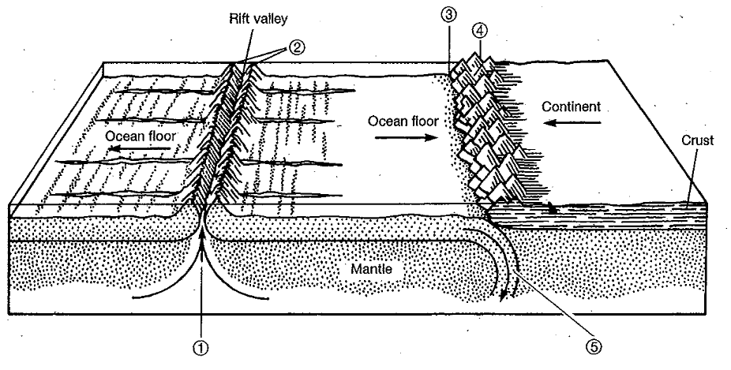

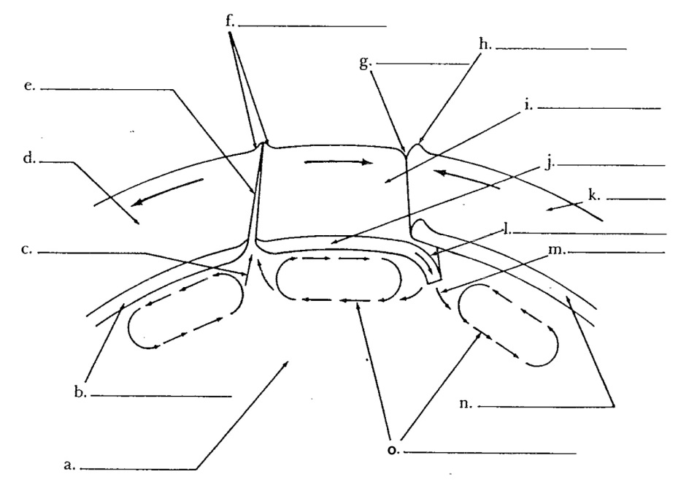
- Fill in the spaces labelled a-o in the diagram using the following terms:

- Subduction
- Ocean floor
- Lithospheric plate
- Mountain range
- Mantle
- Ocean floor
- Rift
- Lithospheric plate
- Mantle convection
- Mid-ocean ridge
- Lithospheric plate
- Trench
- Continent
- Old ocean floor becomes partially molten rock
- Partially molten rock becomes new ocean floor

--------------------------------------------------------------------------------------------------------------------------------------------------
ANSWERS
- Inner core (solid) outer core (liquid) lower mantle (solid) upper mantle [partially melted (asthenosphere) and solid (part included in lithosphere)] crust (solid)
- Fixism: the idea that the continents and oceans have always been in the same place since Earth first formed
- Supercontinent (all the continents were joined) that existed about 200 million years ago
- 5 pieces of evidence: i) continents looked like they fit together (jigsaw puzzle) ii) matching geological structures and rocks on separate continents iii) matching fossils on separate continents) iv) evidence of glaciers in tropical areas v) Coal deposits in Antarctica
- Wegener said that the continents could move but had no mechanism or way to explain HOW they moved
- Sea floor spreading is magma coming up through the rift. This pushes the old rock in opposite direction from the ridge. The magma cools/hardens and forms new rock (mid-ocean ridge). This occurs at divergent plate boundaries
- Closest to mid-ocean ridges = youngest rock, furthest away from the mid-ocean ridge= oldest rock
- That the earth is broken into moveable slabs called tectonic plates. Evidence: Sea floor spreading, mantle convection, location of volcanoes and earthquakes
- Tectonic plates
- Lithosphere is the crust (oceanic or continental) and top part of the upper mantle. The lithosphere is solid. The asthenosphere is also part of the upper mantle but is partially melted (toothpaste consistency). The broken lithosphere makes up the tectonic plates which move over the asthenosphere
- Continental crust is made out of granite and is less dense than continental crust which is made out of basalt. Continental crust is also thicker than oceanic crust

Convergent Plate Boundary | subduction creates sea trenches, Island volcanoes, continental volcanoes, mountain ranges, earthquakes
Divergent Plate Boundary | Mid-ocean ridges (new oceanic crust), rifting, new oceans, volcanoes
Transform boundaries | earthquakes
- Subduction is when the more dense plate goes below a less dense plate. It occurs at convergent plate boundaries. Subduction creates sea trenches where the plates collide. Subduction also can form volcanoes as the leading edge of the subducting plate can melt as it goes further into the earth creating magma
- Mantle convection occurs because warm material is less dense and rises while cooler material is more dense and sinks. The energy comes from the Earth’s interior/core which heats up the mantle. This creates a convection current which helps move tectonic plates in two ways: 1) ridge push: the magma rises through a rift and pushes the tectonic plates apart occurs at divergent boundaries ii) slab pull: the leading edge of the subducting plate sinks and pulls the rest of the plate occurs at convergent boundaries
- Too much stress or too much force too quickly causes the rock to break causing an earthquake
- Focus is where the earthquake starts in the ground. Epicenter is the location directly above where the earthquakes on the surface
- A fault is a break in the rock where movement occurs
Reverse Fault | One block rises due to compression | Causes horizontal shortening of crust
Normal Fault | One block falls due to tension | Crust lengthens
Strike-slip | Blocks move past each other horizontally due to shearing | Torn

Primary (P) waves | Fastest | Solids and liquids
Secondary waves | Slower | Solids (no outer core!)
Surface waves – most damaging! | Slowest | Solids (no outer core!)
- Detect ground motion (earthquakes) amplify this motion and record it
- 3 4 5 6. Each arrow is equal to x10. So 10 x 10 x 10 = 1000 times larger
- At oceanic vs oceanic plate boundaries and continental vs oceanic plate boundaries
- The denser crust subducts (oceanic crust or the older oceanic crust) under the less dense (continental crust or the younger oceanic crust) crust. The leading subducting edge heats up as it goes into the earth and can melt. This melted crust creates magma which can make it’s way to the surface.
- Hot spots are unusually hot regions of Earth’s mantle; they do not move. The magma rises at these spots to the surface by breaking through weak spots of the lithosphere. The tectonic plate moves slowly over this hotspot which creates a volcano. As the tectonic plate moves, the current volcano will eventually not be on hot spot and the volcano becomes inactive since it does not have access to any more magma. The new part of the tectonic plate now over the hot spot can form another volcano. This creates an island chain

Composite Volcano | Convergent plate boundary/subduction zone | Steep sided, tall, symmetrical, thick lava, strata, explosive eruptions
Shield Volcano | Formed at hot spots | Long gentle slopes, low profile, fluid lava, eruptions less explosive.
Cinder Cone Volcano | Often on the side of existing volcanos | Steep cone shape, large craters, majority erupt once, made out of cinder
- a) divergent boundary b) convergent boundary c) divergent boundary d) transform boundary
- a) new magma is pushing up, creating a new ocean floor b)mid-ocean ridge which is becoming higher and wider. Creates a new ocean floor c) Trench d)a mountain range. The underlying plate at the subduction zone is pushing the upper plate upwards e) old ocean floor is melting into magma

- Mantle | b) Lithospheric plate | c) partially molten rock/ new ocean floor
d) ocean floor | e) rift | f) mid-ocean ridge | g) trench
h) mountain range | i) ocean floor | j) lithospheric plate | k) continent
l) subduction | m) old ocean floor becomes molten rock |  | n)lithospheric plate
o) mantle convection

