**WAVES_______________________________________________ _________________________________________________**

Name: ___________________

1. Label the following diagram

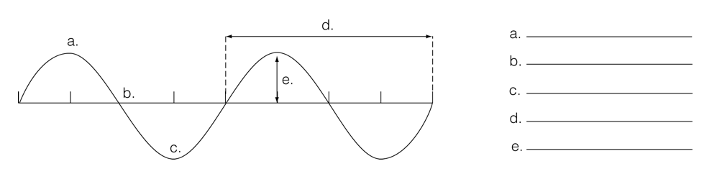

1. Using the diagram the above, if I told you the line was 4 seconds, what is the frequency of the wave?
2. Which of the following is **not true** about compression waves
3. It is a type of mechanical wave C. Matter moves perpendicular to the wave direction
4. The particles are crowded at the compression D. The particles are spread apart at the rarefaction
5. Which of the following is **not** an electromagnetic wave?
6. Ultraviolet wave B. Transverse wave C. Radio wave D. Visible light
7. What happens when the amplitude of a wave decreases?
8. The amount of energy in the wave increases C. the height of the crests increases
9. The wavelength decreases D. the frequency increases
10. List the following types of radiation from LONGEST to SHORTEST wavelength: gamma rays, infrared waves, radio waves, X-rays, ultraviolet rays, visible light – then give one use for each type.

|  |  |
| --- | --- |
| *Radiation* | *Use* |
| a) |  |
| b) |  |
| c) |  |
| d) |  |
| e) |  |
| f) |  |

1. What are the colors in the visible spectrum, from longest wavelength to shortest? ____________________________
2. What is the name of the clear objects that can separate light into colors? _____________
3. Why does a blue car appear to be blue in the sunlight?

|  |
| --- |
| 1. The car **reflects** all the colours of the visible spectrum |
| 1. The car **absorbs** the colour blue and reflects colours other than blue 2. The car **refracts** the colour blue and reflects colours other than blue 3. The car **reflects** the colour blue and absorbs colours other than blue 4. Which of the following is not an additive primary colour? |

1. Red B. Yellow C. Blue D. Green
2. Are the following objects transparent (T), Translucent (Tl) or opaque (O)
3. _____ glass B. _____ stained glass window C. _____ cardboard D. _____ mirror
4. To create a larger shadow, the object must
5. go further away from the light source B. go closer to the light source

|  |  |
| --- | --- |
| 1. ______ crest | 1. distance from crest to crest on a wave |
| 1. ______ amplitude | 1. Light waves we can see (colours) |
| 1. ______ frequency | 1. Highest part of a wave |
| 1. ______ trough | 1. Height of a wave crest or depth of a trough |
| 1. ______ wavelength | 1. Scatters light rays that pass through |
| 1. ______ translucent 2. ______ transparent 3. ______ opaque 4. ______ Ray Model of Light | 1. Lowest part of a wave 2. Shows the direction light travels by using a straight line 3. Allows light to pass through 4. the number of cycles per second |
| 1. ______ visible light | 1. does not allow any light to pass through |

1. Which term describes light bouncing off a surface?
2. rarefaction B. refraction C. reflection D. translucent
3. On a smooth plane mirror, if the angle of incidence is 60o then the angle of reflection is
4. 30o B. 60o C. 90o D. 180o
5. Which statement best defines “medium”
6. A push or pull on an object
7. The number of cycles that occur in a given time
8. The capacity to apply a force over distance
9. The matter that waves travel through
10. Light travels from water (more dense) to air (less dense), it refracts (bends)…
11. Toward the normal C. toward the less dense substance
12. Away from the normal D. away from the reflective surface

**OPTICS____________________________________________________________________________________________**

1. Which statement is **not** true of real images
2. image is upright C. image is always be behind a lens or in front of a mirror
3. the image can be projected onto a wall D. light rays converge at a real focus point
4. Label the following mirrors as convex or concave and draw the path of the incident and reflected rays. For each tell me if the rays converge or diverge

a) b)

1. Draw a concave and concave lens below. Show and label whether each causes light to diverge or converge
2. Concave lens b) convex lens
3. 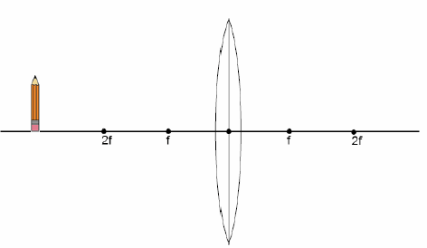Complete the ray diagram.

Image is:

Real / Virtual / No Image

Upright / Inverted

Smaller / Larger / Same size

Light converges/diverges

1. Complete the ray diagram

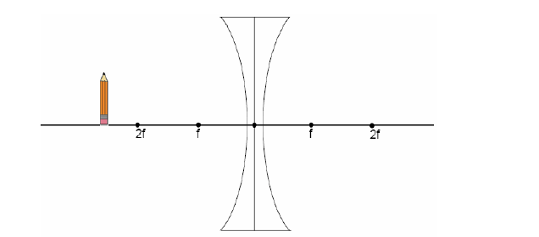

Image is:

Real / Virtual / No Image

Upright / Inverted

Smaller / Larger / Same size

Light converges/diverges

1. An example use for a concave mirror is:
   1. Side view mirrors on cars B. flashlight
   2. Back of a metal spoon D. shiny glass ball
2. An example use for a convex mirror is:
   1. Security mirror B. car headlights
   2. Makeup/shaving mirrors D. spot light

|  |  |
| --- | --- |
| 1. ______ incident ray | 1. ray striking a reflecting or refracting material |
| 1. ______ reflected ray | 1. imaginary line perpendicular to a reflecting or refracting surface |
| 1. ______ refracted ray | 1. curved inward |
| 1. ______ concave | 1. spreading apart |
| 1. ______ converging | 1. light ray that passes through a lens |
| 1. ______ convex | 1. where converging rays meet |
| 1. ______ diverging | 1. Light rays do not actually converge, image always upright |
| 1. ______ focal point | 1. curved transparent material that refracts light |
| 1. ______ real image | 1. Upside down |
| 1. ______ normal 2. ______ lens 3. ______ virtual image 4. ______ inverted | 1. light ray that reflects from a mirror 2. curved outwards 3. come together at a point 4. Light rays actually converge at a focal point, image always inverted |

**HUMAN VISION_______________________________________________________________________________________**

1. The order in which light travels through the eye, from outside to the optic nerve (including humors) is:

OUTSIDE 🡪 A.______________ 🡪 B.__________________________ 🡪 C.________________ 🡪D. _________________ 🡪E. ___________________ 🡪F. ______________ 🡪 Optic Nerve

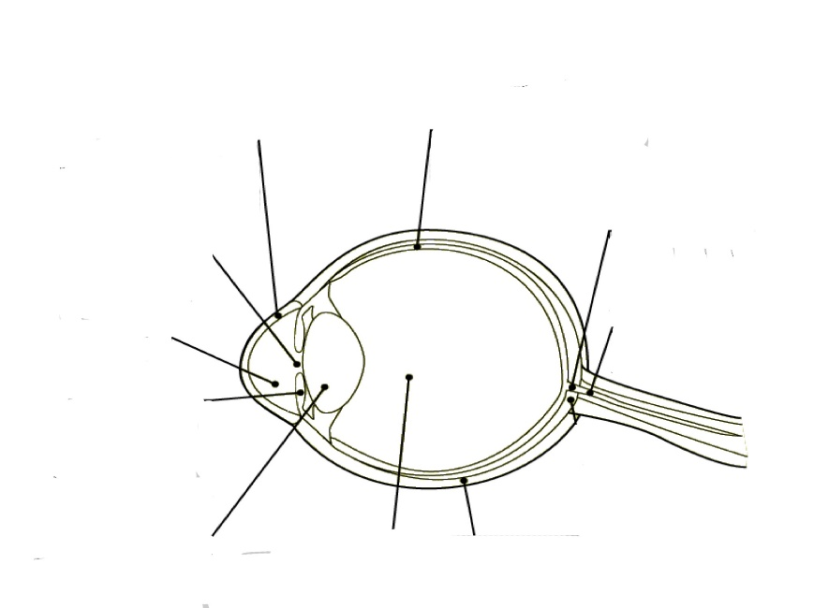Use the diagram to the left to answer the following questions:

J

A

1. Retina i. A ii. D iii. C iv. J
2. Cornea i. G ii. F iii. H iv. J

I

B

1. Blind spot i. C ii. B iii. G iv. I
2. The lens i. F ii. E iii. H iv. C

C

1. The sclera i. D ii. A iii. J iv. G

H

1. Vitreous humor i. H ii. E iii. F iv. B
2. Pupil i. F ii. G iii. I iv. B

G

1. Aqueous humor i. E ii. F iii. G iv. H
2. Optic nerve i. B ii. C iii. H iv. A
3. Iris i. J ii. D iii. G iv. F

F

E

D

|  |  |
| --- | --- |
| 1. ______ astigmatism | 1. where the optic nerve attaches on the retina |
| 1. ______ blind spot | 1. hole where light enters the eye |
| 1. ______ cornea | 1. blurred vision caused by an oval cornea |
| 1. ______ iris | 1. transparent tissue covering the eye |
| 1. ______ optic nerve | 1. Jelly that gives the eye its shape |
| 1. ______ pupil | 1. sends messages from the eye to the brain |
| 1. ______ retina | 1. coloured muscle that controls the amount of light entering the eye |
| 1. ______ sclera 2. ______ aqueous humor 3. ______ vitreous humor | 1. Liquid that provides nutrients to the cornea 2. opaque white tissue surrounding the eye 3. Where the light focuses to create an image |

1. The part of the eye that allows us to detect color…
2. Rod cells B. Cornea C. Sclera D. Cone cells
3. The part of the eye that allows us to detect light and dark…
4. Rod cells B. Cornea C. Sclera D. Cone cells
5. The image that forms in the eye on the retina is…

(F)

A. upside down and backwards B. right side up C. backwards D. inverted

1. Most of the focusing (refraction) of light is done by the…
2. Lens B. Retina C. Sclera D. Cornea
3. The fine tune focusing (refraction) of light is done by the…
   1. Lens B. Retina C. Sclera D. Cornea
4. What problem in the eye causes farsightedness? How do we correct it?
5. What problem in the eye causes nearsightedness? How do we correct it?

**Answers**

|  |  |  |  |  |  |  |  |
| --- | --- | --- | --- | --- | --- | --- | --- |
| 1a) crest | 5d) ultraviolet, vit D, forensics | 11) B | 25) B | 29. real, inverted, smaller, converges | 41) M | 48) iv | 62) B |
| 1b) resting positon | 12) C | 26) A | 42) B | 49) ii | 63) J |
| 1c) trough | 5e) x-rays, pics of bones | 13) D | 27a) convex  diverge | 30. virtual, upright, smaller, diverges | 43) H | 50) i | 64) I |
| 1d) wavelength | 14) I | 44) G | 51) i | 65)H |
| 1e) amplitude | 5f) gamma rays, cancer treatment | 15) F | 31) B | 45) I | 52) ii | 66)E |
| 1f) 0.5Hz | 16) A | 27b) concave  converge | 32) A | 46a) cornea | 53)iii | 67)D |
| 2) C | 6) ROY G. BIV | 17) E | 33) A | 46b) aqueous humor | 54) iv | 68)B |
| 3) B | 7) prism | 18) H | 34) J | 55) ii | 69)D |
| 4) D | 8) D | 19) J | Image result for concave lens28a) concave  diverge | 35) E | 46c) pupil | 56) iii | 70)D |
| 5a) radio, TV, radar | 9) B | 20) G | 36) C | 46d) lens | 57) C | 71)A |
| 5b) microwave, microwave | 10a) T | 21) B | 37) L | 46e) virtuous humor | 58) A | 72) focus behind retina ,convex lens |
| 10b) TL | 22) C | Image result for convex lens28b) convex  converge | 38) K | 59) D |
| 5c) infrared, heat radiation, remotes | 10c) O | 23) B | 39) D | 46f) retina | 60) G | 73)focus in front of retina, concave lens |
| 10d) O | 24) D | 40) F | 47) i | 61) F |