NOTES 5.6 Properties of Linear Relations
1. Which table of values represents a linear relation? Justify your answer.

a) The relation between the number of bacteria in a culture, n, and time, t minutes.
t | n
0 | 1
20 | 2
40 | 4
60 | 8
80 | 16
100 | 32
b) The relation between the amount of goods and services tax charged, T dollars, and the amount of the purchase, A dollars

A | T
60 | 3
120 | 6
180 | 9
240 | 12
300 | 15

2. a) Graph each equation.
i) x = –2 ii) y = x + 25

iii) y = 25 iv) y = x² + 25

b) Which equations in part a represent linear relations? How do you know?
3. Which relation is linear? Justify your answer.
a) A dogsled moves at an average speed of 10 km/h along a frozen river. The distance travelled is related to time.

b) The area of a square is related to the side length of the square.

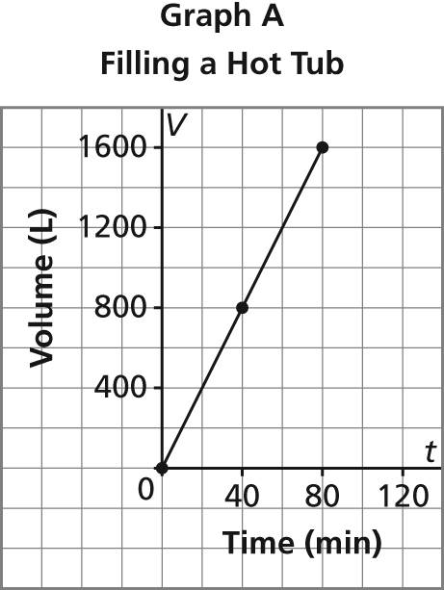
4. A hot tub contains 1600 L of water.
Graph A represents the hot tub being filled at a constant rate.
Graph B represents the hot tub being emptied at a constant rate.
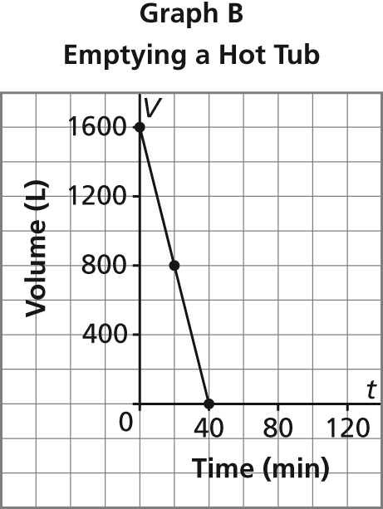

a) Identify the dependent and independent variables.
b) Determine the rate of change of each relation, then describe what it represents.

