NOTES 5.7 Interpreting graphs of linear functions
1. This graph shows how the height of a burning candle changes with time.
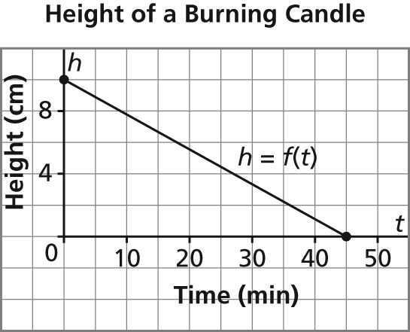
a) Write the coordinates of the points where the graph intersects the axes. Determine the vertical and horizontal intercepts. Describe what the points of intersection represent.
b) What are the domain and range of this function?

2. Sketch a graph of the linear function f(x) = 4x – 3.

3. Which graph has a rate of change of –5 and a vertical intercept of 100? Justify your answer.
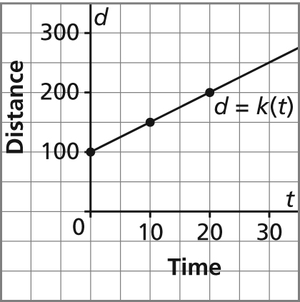
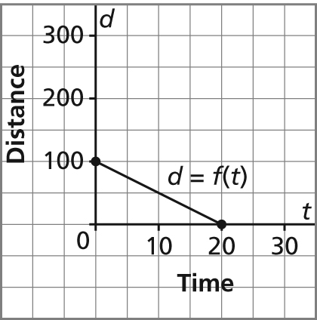
a) b)

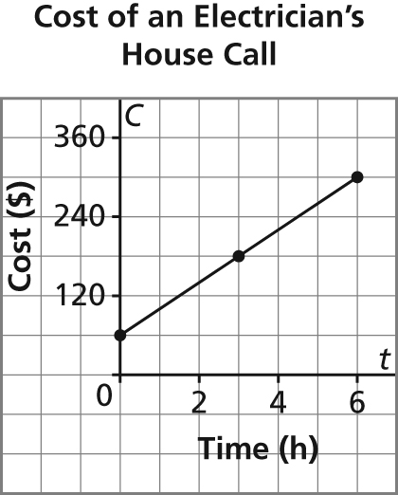
4. This graph shows the total cost for a house call by an electrician for up to 6 h work. The electrician charges $190 to complete a job. For how many hours did she work?

