MC900290272[1]Assignment #4: Radicals /18

**MULTIPLE CHOICE (2 marks)**

tg_c04_m04-t01tg_c04_m04-t02**1.** Which length is an irrational number?

**A.** **B.**

tg_c04_m04-t03tg_c04_m04-t04 **C.** **D.**

**2.** Which expression is equal to 

**A.**  **B.**  **C.**  **D.** 

**SHORT ANSWER (16 marks)**

**3. a)** Which number has been incorrectly located? Identify the number and mark its correct location.

(2 marks)

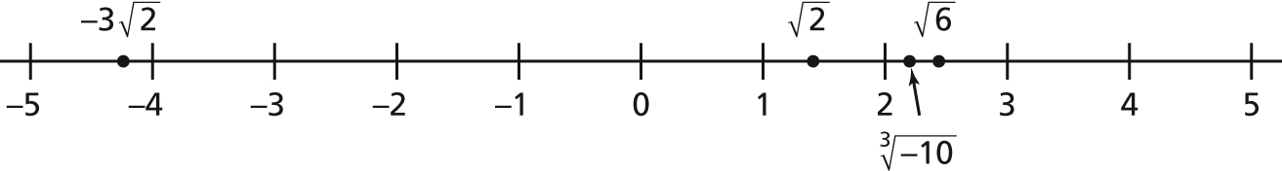

**b)** Where would you locate ? Justify your answer. (2 marks)

**4.** Evaluate without using a calculator. (4 marks)

**a)**  **b)** 

**c)**  **d)** 

**5.** A student simplified ****as follows:

**=** 

= 

= 

= 

Identify the errors in this solution, then write a correct solution. (2 marks)

**6.** Rewrite  as a radical, then evaluate the radical. (2 marks)

**7.** Simplify. Which exponent laws did you use? (4 marks)

**a)**  **b)** 