MC900290272[1]Assignment #5: Relations & Functions /32

**MULTIPLE CHOICE (2 marks)**

**1.** How many of these equations represent a linear function?  
 *y* = –5*x* + 8 *g*(*x*) = 2  
 *y* = *x*2 – 5 *x* = –1  
**A.** 1 **B.** 2 **C.** 3 **D.** 4

**2.** For the function *f*(*x*) = 2*x* – 3, what is the value of *x* when *f*(*x*) = 15?  
**A.** 27 **B.** 6 **C.** 9 **D.** –9

**SHORT ANSWER (30 marks)**

**3.** For each relation represented below: (13 marks)

**i)** State whether it is a function and how you know.

**ii)** If the relation is a function:

* State its domain and range.
* Represent the function a different way.
* State whether it is a linear function and how you know.

**iii)** If the relation is a linear function:

* Identify the dependent and independent variables.
* 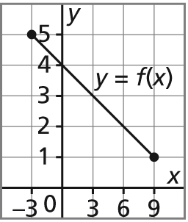Determine the rate of change.

**a) b)**

|  |  |
| --- | --- |
| ***a*** | ***b*** |
| 1 | 3 |
| 3 | 6 |
| 5 | 9 |
| 7 | 12 |

**c)** {(0, 2), (2, 4), (4, 6), (0, –2), (2, –4), (4, –6)}

**4.** Use the distance-time graph below to explain what the graph represents. (5 marks)

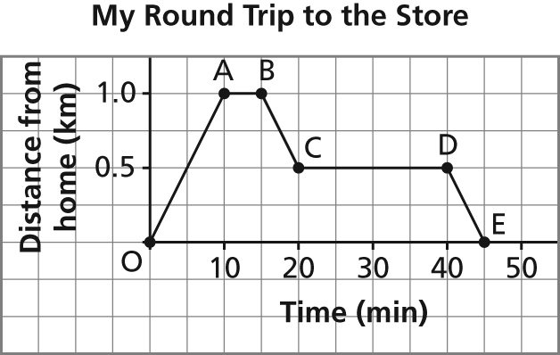

|  |  |  |
| --- | --- | --- |
| **Segment** | **Journey** | **Graph** |
| OA |  |  |
| AB |  |  |
| BC |  |  |
| CD |  |  |
| DE |  |  |

**5.** This table of values shows how the profit from the sale of T-shirts relates to   
the number of T-shirts sold.

|  |  |  |  |  |  |  |  |
| --- | --- | --- | --- | --- | --- | --- | --- |
| **Number of  T-Shirts Sold, *n*** | 0 | 1 | 2 | 3 | 4 | 5 | 6 |
| **Profit ($), *P*** | –20 | –15 | –10 | –5 | 0 | 5 | 10 |

**a)** What does a negative profit indicate? (1 mark)

**b)** Graph the data (3 marks). Did you connect the points? Explain. (1 mark)



**c)** Determine the domain and range. (2 marks) Could you extend the graph? Identify and explain any restrictions on the domain and range. (2 marks)

**d)** Determine the rate of change for this function. What does it represent? (2 marks)

**e)** Suppose the table is extended. **i)** What is the profit on the sale of 64 T-shirts? (2 marks)

**ii)** How many T-shirts must be sold to make a profit of $325? (2 marks)