4.1 Writing Equations to Describe Patterns
FINDING PATTERNS

Jumpstart Your Thinking
Follow the pattern to draw the next two figures in the series.

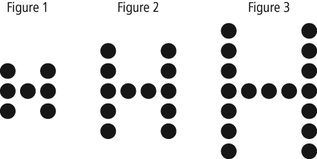

Describe, in words, the relationship between the figure number and the number of dots in each figure.

Let’s Look at the Math

Finding patterns is a big part of mathematics. There are some really famous patterns such as the Fibonacci Sequence that explain some phenomenom in nature. We can represent patterns in a number of different ways:
- Using pictures
- Using words
- Using a table of values
- Using an equation

1. Each square in the pattern has a side length of 1 cm.

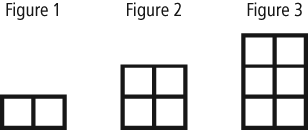

a) Create a table comparing the figure number with the area for that figure. Extend the table to include the next two figures in the pattern.

Figure Number, f | Area, a  (cm²)

b) What is a linear equation that represents this pattern?

2. Theater tickets cost $65.00 each. Complete the table of values.

Number of Tickets, n | Cost, C ($)
1
2
3
4
5
b) What is a linear equation that represents this pattern?

USING EQUATIONS FOR PATTERNS

Jumpstart Your Thinking

3. The pattern in this table continues. Which equation below relates the figure number n, to the perimeter of the figure P?

Figure Number, n | Perimeter, P
1 | 7
2 | 10
3 | 13
4 | 16

a) P = 3n + 7 b) P = 7n + 3 c) P = 3n + 4 d) n = 3P + 7

Let’s Look at the Math
4. In each equation, determine the value of A when n is 3.

a) A = 2n + 1 b) A = 3n – 2

Term Number, t | Term Value, v
1 | 8
2 | 13
3 | 18
4 | 23
5. The pattern in the table below continues. For the table:

i) Describe the pattern that relates v to t.

ii) Write an equation that relates v to t.

iii) Verify your equation by substituting values from the table.

6. Rachel takes care of homes during the summer while their owners are away on vacation.
She charges $8, plus $2.50 a day.
a) Create a table that shows the charges when the owners are away for up to 5 days.

Number of Days, d | Charge, C

b) Write an equation that relates the charge, C dollars, to the number of days, d,
that the owners are away.

c) What will the charge be when the owners are away for 14 days?

d) How many days were the owners away when the charge was $33?

