4.5 Using Graphs to Estimate Values
Jumpstart Your Thinking
Which equation describes this graph? Justify your answers.
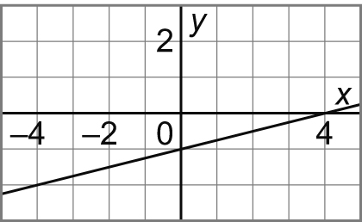a) x – y = 4

b) x – 4y = 4

c) 4x – y = 1

Let’s Look at the Math
Graphs are very useful ways of organizing information in a visual format. Sometimes we can just use the graph to answer our questions directly and not worry about an equation; these processes are called:

Interpolation: ___________________________________________________________

______________________________________________________________________

Extrapolation: ___________________________________________________________

______________________________________________________________________
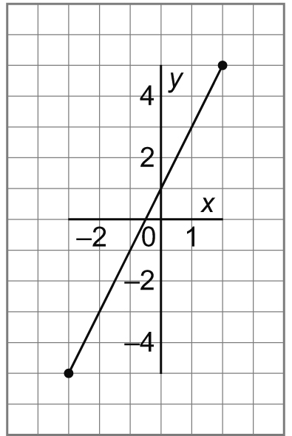1 This graph represents a linear relation.
Is this interpolation or extrapolation?
a) Determine the value of x for each value of y.
i) y = 3 ii) y = –2 iii) y = 7

b) Determine the value of y for each value of x.
i) x = 0 ii) x = –2 iii) x = –4

2. The graph shows how the cost of a long distance call changes with the time for the call.
a) Estimate the cost of a 7-min call.
Is this interpolation or extrapolation? Explain.
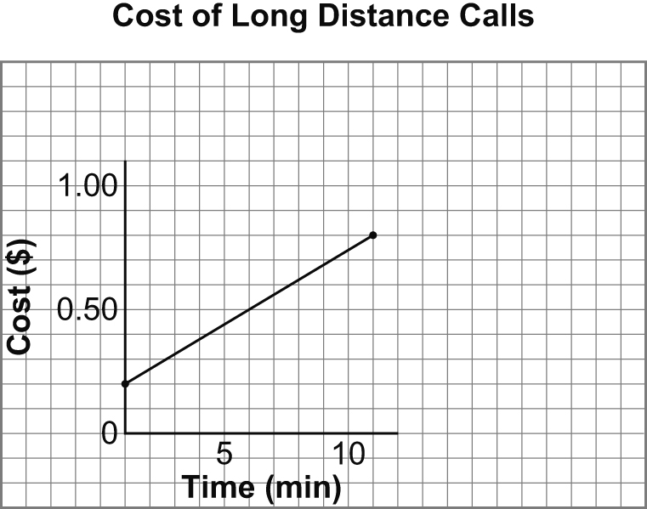

b) The cost of a call was $1.00.
Estimate the time for the call.

c) The cost of a call was $1.50.
Estimate the time for the call.

