Notes: 3.5 Algebra Tiles

Polynomials of the form x² + bx + c
- Each large square has a length of x units and a width of x units
- Each rectangle has a length of x units and a width of 1 unit
- Each small square has a length of 1 unit and a width of 1 unit

x 1 1 -x -1 -1

1 -1
x x -x -x

To Factor polynomials of the form x² + bx + c (ex. x² + 6x + 8), shape your tiles into a perfect rectangle.

When multiplying:
1st: Set up the dimensions of the rectangle by placing the terms of one factor along the TOP
2nd: Place the other factor along the LEFT side
3rd: Complete the rectangle
4th: Solve

Ex. #3 Expand: (5e + 3)(2e + 4)

Solve using distributive property
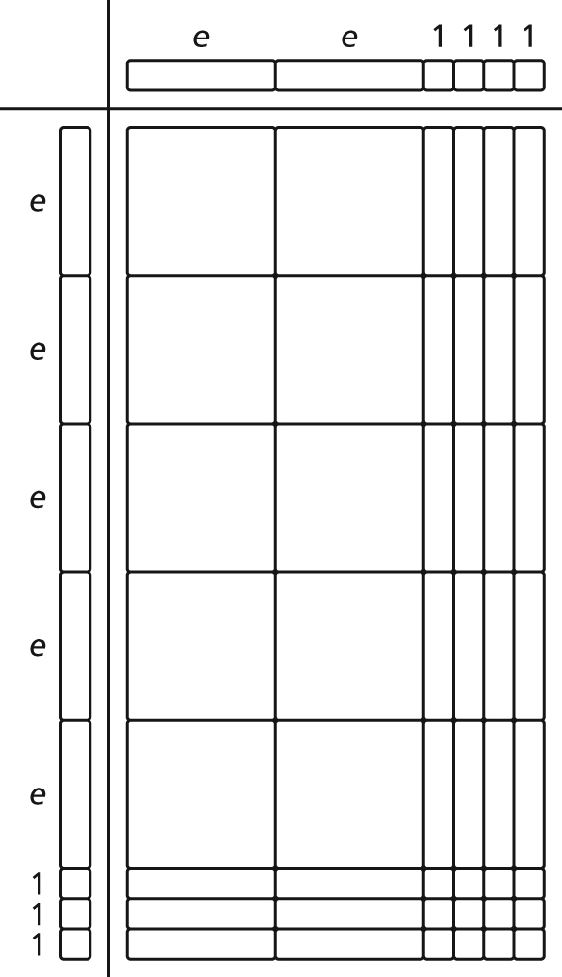

Complete the following table:
FACTORS | TILE MODEL | SOLVE  Check your answer!
(2x+1)(x+1) |  | *use distributive property
(x-1)(-4x+1)
(2x+1)(x-2)
(x-3)(-x-1)

